Leave that book at school and always have an e-copy by following these simple instructions
First, go to this web-address: https://clever.com/in/bssdr4
The log-in page will look like this:
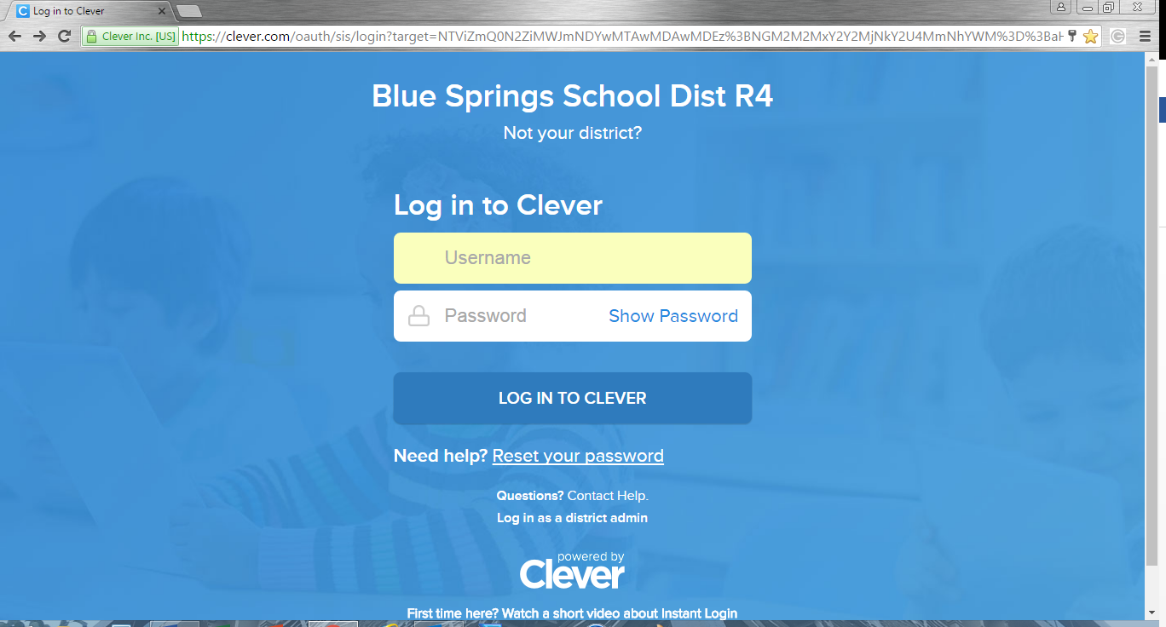

Username: Lunch # (Student ID)
Password: Lunch # (Student ID)
After logging in, you will go to your students’ school and book already assigned to them.
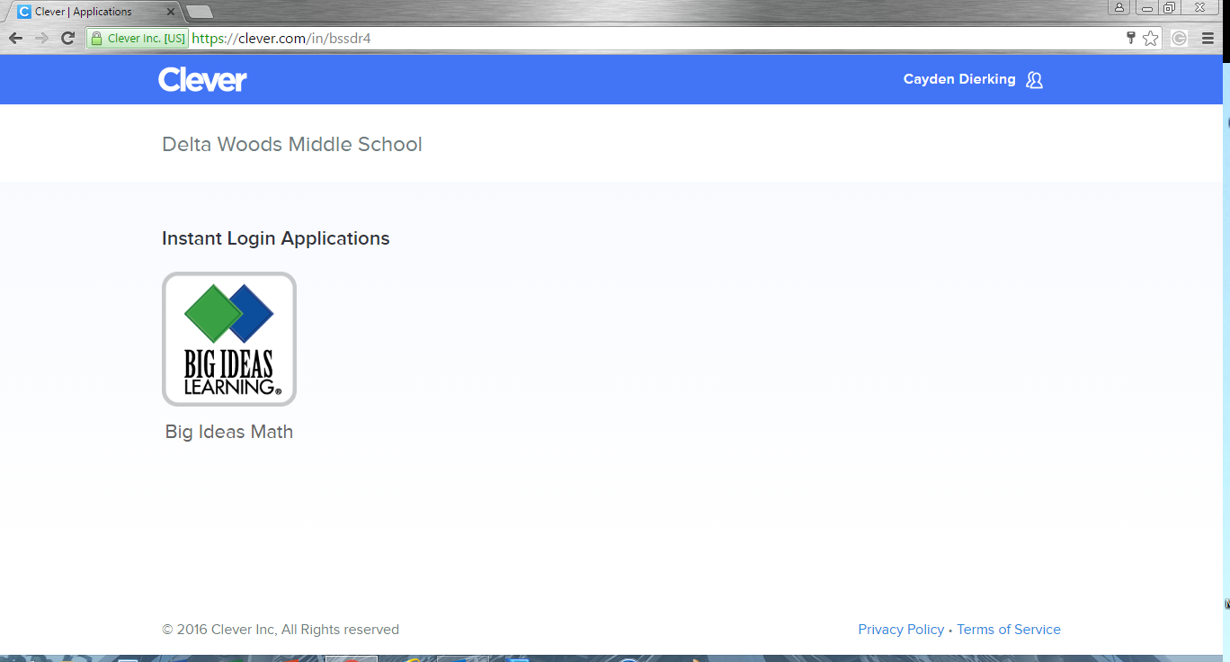

After clicking the Big Ideas Math Launch button, you will see there are many great resources, apps, organizers, online resources. The first icon, Student Dynamic eBook, will allow students to have total access to the entire book online. The very last icon, Download eBook, allows students to download a copy of the textbook directly to their device.
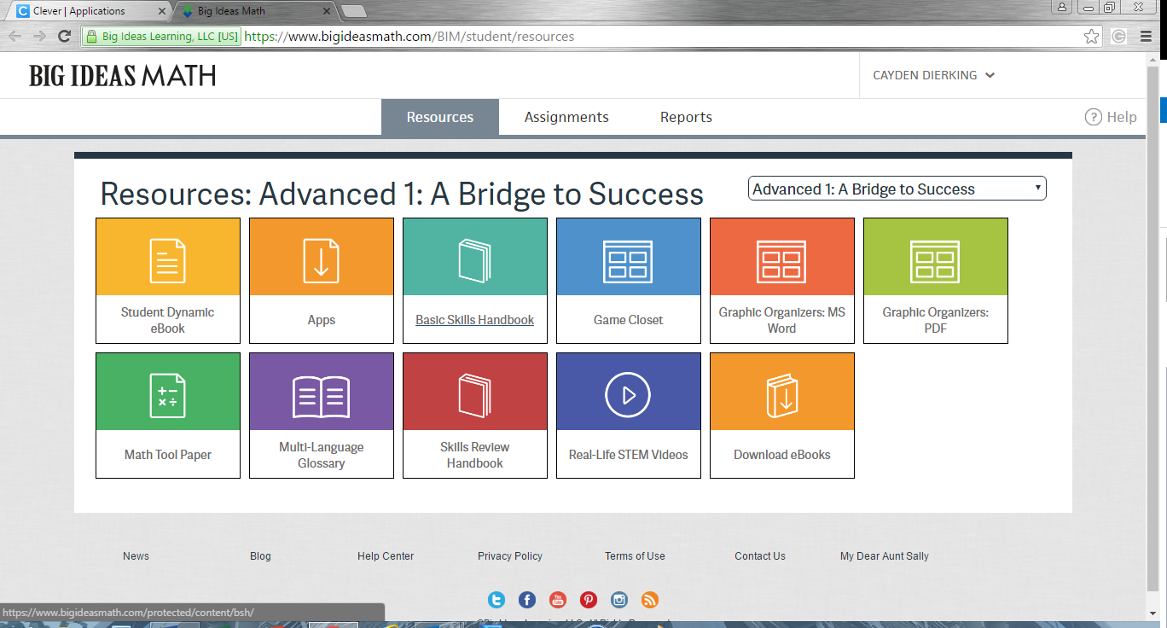

If you would like to download the book to your device, follow these instructions:
After clicking on the Download eBooks launch button, you will be directed to the actual download page. There are directions for PC / Mac / iPad / MacBook / etc.
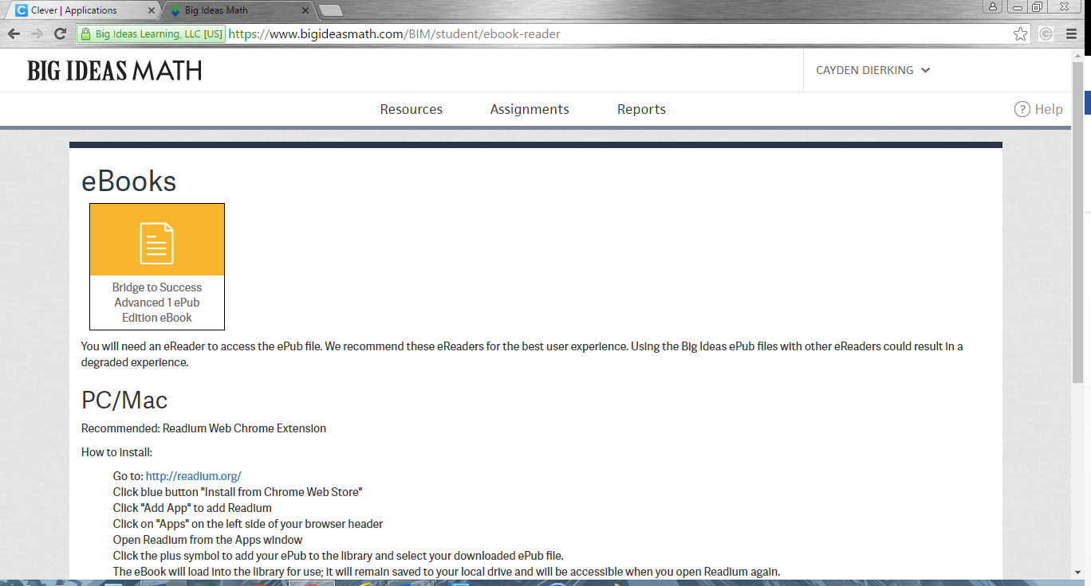

After starting the download, the directions on the page will have you import the book through the Google App, Readium. Most devices already have a reader, but if not, this is a great APP.
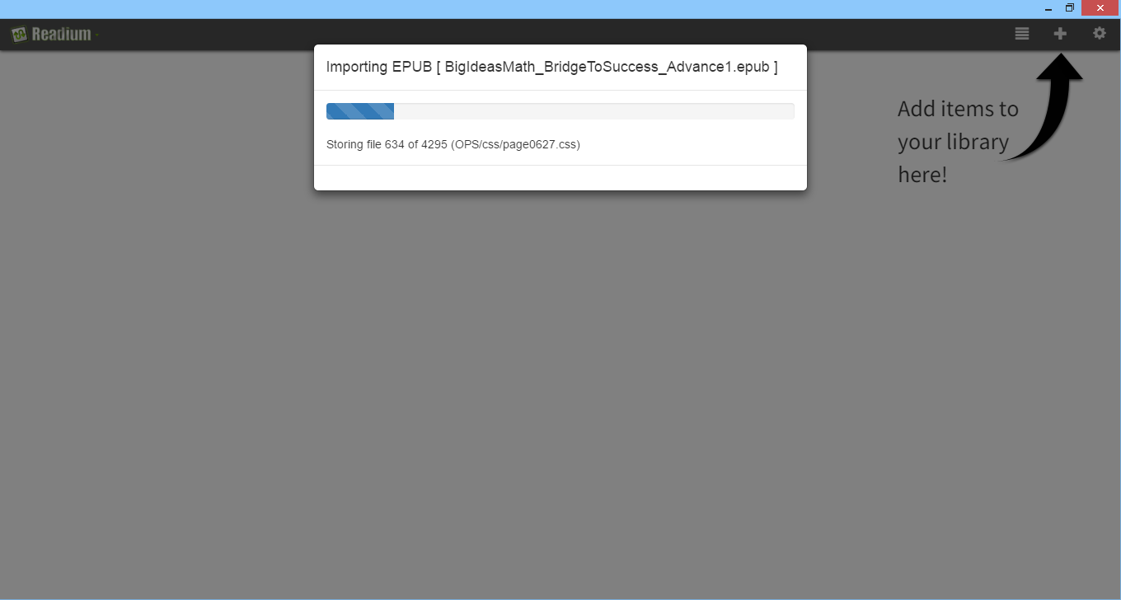

After a few moments, the full version of your child’s book is now on your device ready to use.
Here is a sample of one of the eBook pages.
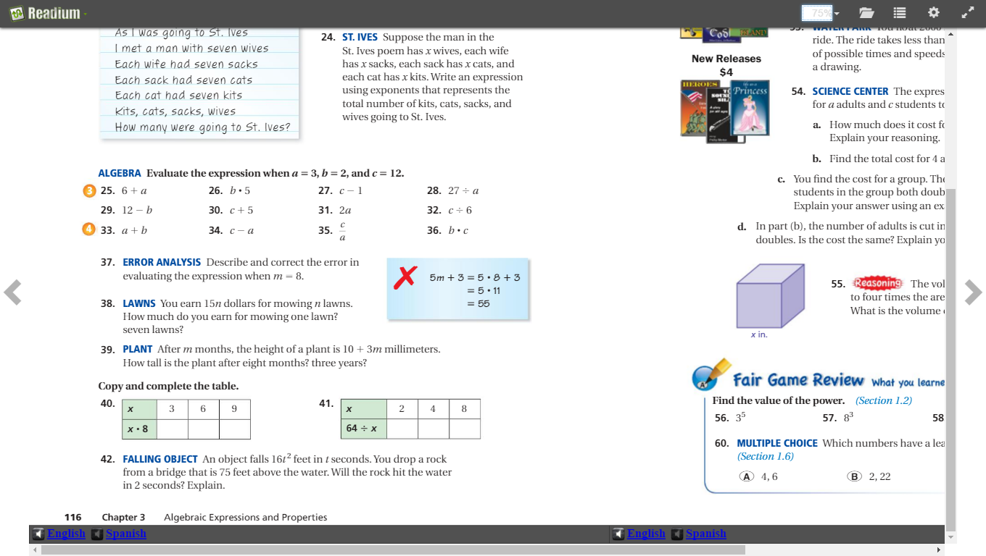
It is the exact book we use in class, just more environmentally friendly, easier than lugging that heavy book home, and without the worry of damaging the book or paying for a costly obligation at the end of the year if something happens.

